# **Name: Vaibhav Jain**

# **Registration No.: RA2011028010103**

**Department: CSE W/S in Cloud Computing**

EXPERIMENT - 1

# Aim: Install and learn using AWS CLI

# 

# 

# 

# 

1. AWS Help:

the built-in help command for the AWS CLI. When using the AWS Command Line Interface, you can obtain assistance with any command (AWS CLI). Simply put help after a command name to do so. For instance, the following command shows guidance for the top-level commands and common AWS CLI parameters.

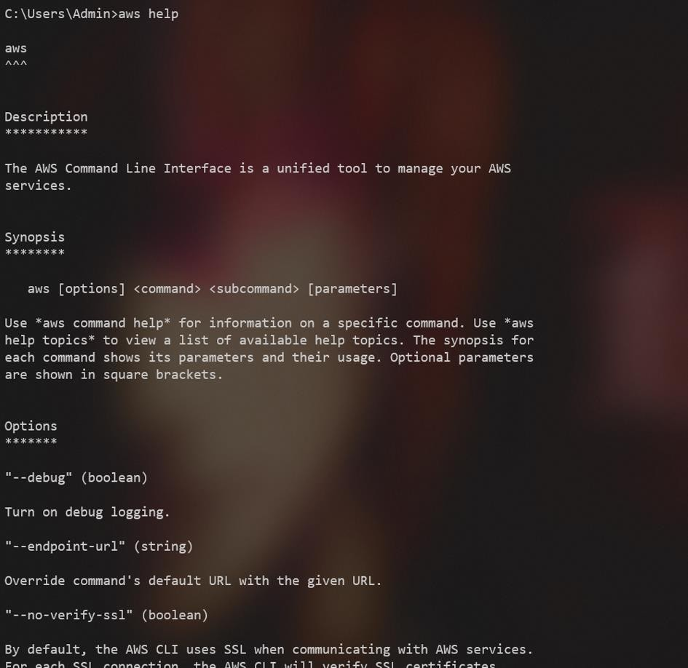

# AWS – version

The most recent major version of the AWS CLI, version 2, supports all of the newest features.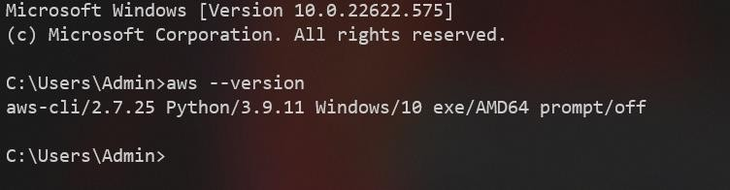

# AWS configure

You may analyse, audit, and evaluate the configurations of your AWS resources using the service known as AWS Config. Config allows you to automate the comparison of recorded configurations to desired configurations while continuously monitoring and recording your AWS resource configurations.

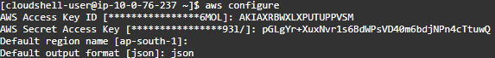

# sts get-caller-identity

Run the sts get-caller-identity command with the —query argument set to Account to filter the results in order to obtain your account id using the AWS CLI. Copied! The get-caller-identity command provides the caller's User Id, Account Id, and ARN.

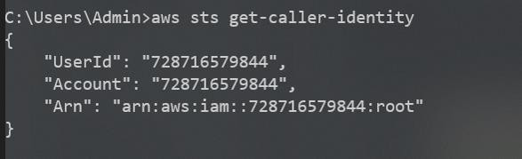

# aws s3 ls

Use the s3 ls command to see a list of your buckets, folders, or objects. All buckets are listed when the command is used without a target or arguments.



# aws s3 ls bucketName

The ls command lists all items and common prefixes that fall under the given bucket and prefix. The user owns the bucket mybucket in this example, which contains the files test.txt and somePrefix/test.txt. Length and LastWriteTime are arbitrary values. Noting that the s3:/ URI scheme is not necessary to resolve ambiguity and may be eliminated because the ls command does not interface with the local filesystem.



# create bucket

You must sign up for Amazon S3 in order to create buckets, and you must be able to authenticate requests with an active Amazon Web Services Access Key ID. Bucket creation is never permitted for anonymous requests. You acquire ownership of the bucket after you create it. Not all strings are suitable for use as bucket names.

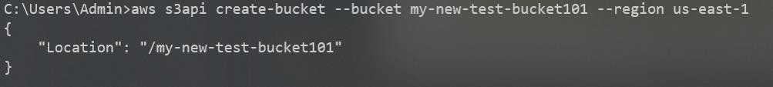

# copy bucket

Use the AWS CLI sync command, specifying the s3 bucket as a source and a directory on your file system as a destination, for example, aws s3 sync s3:/YOUR BUCKET, to download an entire bucket to your local file system.



# delete bucket

If versioning is not enabled for your bucket, you can still destroy the bucket and all of its contents by using the rb (remove bucket) AWS CLI command with the —force parameter. This command deletes the bucket after deleting each object in turn.

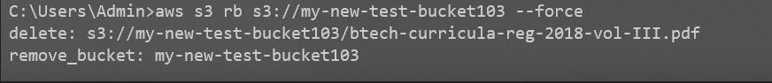

# remove file from bucket

Use the s3 rm command to remove items from a bucket or your local directory. See Frequently used options for s3 commands for a list of popular options to use with this command and examples. See s3 rm in the AWS CLI Command Reference for a comprehensive list of options. The example that follows removes filename

